- Creator: Unknown
Title: “King Andrew I”
Publication: Unknown
Publication Date: 1832
Description: After President Andrew Jackson’s unprecedented veto of the Bank Bill, Jackson was accused of abusing his Presidential powers. His opponents began to refer to him as “King Andrew.” The anti- Jackson material in circulation during Jackson’s Presidency was not only political, but also personal in nature; his political opponents attacked him at a personal level and vice versa. Source: Folder: Cartoon Lesson Plan Standish
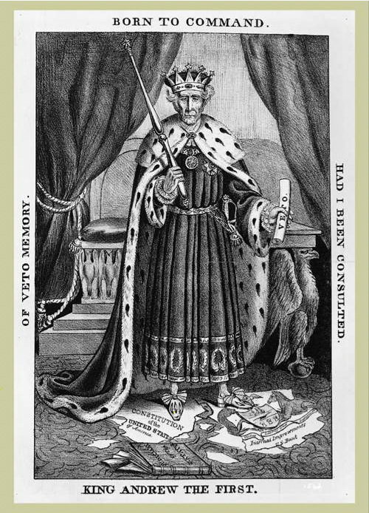
2. Creator: D.C. Johnston Title: “Symptoms of Locked Jaw”
Publication: Unknown
Publication Date: 1834
Description: In 1834, the U.S. Senate took unprecedented action and censured President Andrew Jackson due to his actions to defund the Bank of the United States. A long time political rival, Senator Henry Clay, challenged Jackson on the bank issue in December of 1933 and requested a paper Jackson read to his cabinet. When Jackson refused to provide the paper, Clay introduced the censure resolution. After the Senate agreed to censure the president, Jackson responded with a protest denying the validity of the Senate’s actions. However, the Senate simply refused to print Jackson’s message. The censure was not expunged until 1837. Source: Folder: Cartoon Lesson Plan Standish
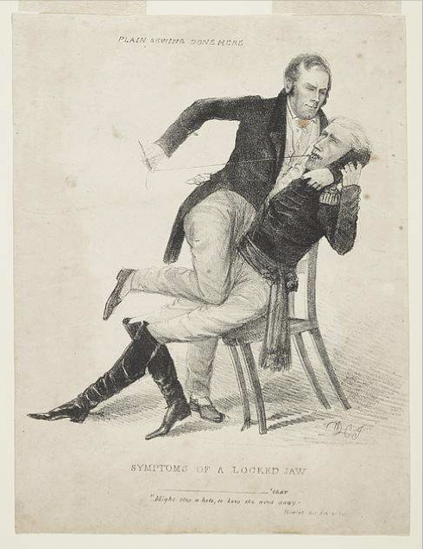
- Creator: Unknown
Title: “Banks: Altar of Reform”
Publication: Unknown
Publication Date: 1831
Description: Jackson sits in a collapsing chair, next to a column labeled “Altar of Reform.” Behind him are nine resignation documents, and below him are rats scurrying away. Each rat is meant to represent one of his cabinet members who resigned during Jackson’s presidency. From left to right, the cabinet members pictured are Secretary of War John E. Eaton, Secretary of the Navy John Branch, Secretary of State Martin Van Buren, and Secretary of Treasury Samuel D. Ingham. In addition to the controversy surrounding Jackson’s stand on the National Bank, there was a personal element in all the anti-Jackson material in circulation because of the contentious relationship between Jackson and his former Vice President John C. Calhoun. Source: Folder: Cartoon Lesson Plan Standish
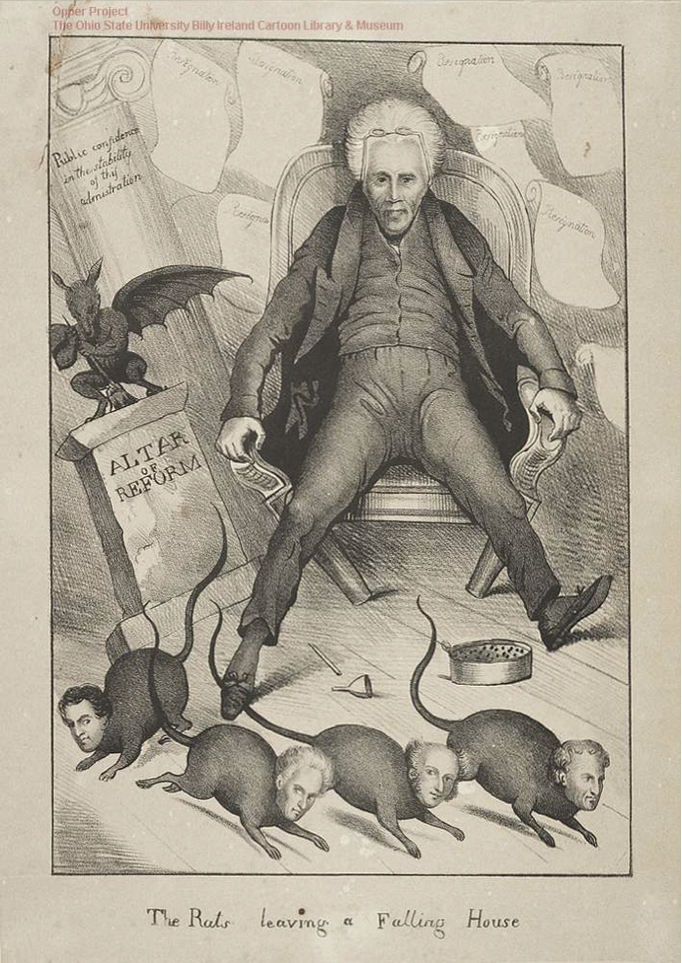
- Creator: Unknown
Title: “Jackson is to be president and you will be hanged”
Publication: Unknown
Publication Date: 1828
Description: The election of 1834 was between three men: John Quincy Adams, Andrew Jackson, and Henry Clay and no nominee received a majority of electoral votes. The outcome then had to be decided by the House of Representatives. After a series of unsuccessful ballots, Adams was eventually elected president and appointed Clay as his Secretary of State. Jackson and his supporters cried foul and argued that Adams and Clay had made a deal to deprive the people of their real choice. This election has come to be known as the “Corrupt Bargain.” Supporters of Jackson and Adams spent the next four years attacking each other. Jacksonians argued that Adams administration was illegitimate and tainted with corruption and aristocracy while supporters of Adams argued that Jackson did not have the qualifications necessary to be President and that his quick temper would be a problem.
Source: Folder: Cartoon Lesson Plan Standish

