Steps to Compromise or War

Indicate if the attempt at compromise had a positive impact on the top line or a negative impact on the bottom line. Be sure to explain your reason for placement on the fishbone.

Compromise of 1850
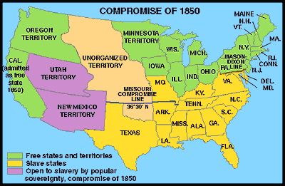
The plan was set forth. The giants — Calhoun, Webster, and Clay — had spoken. Still the Congress debated the contentious issues well into the summer. Each time Clay's Compromise was set forth for a vote, it did not receive a majority. Henry Clay himself had to leave in sickness, before the dispute could be resolved. In his place, Stephen Douglas worked tirelessly to end the fight. On July 9, President Zachary Taylor died of food poisoning. His successor, MILLARD FILLMORE, was much more interested in compromise. The environment for a deal was set. By September, Clay's Compromise became law.
California was admitted to the Union as the 16th free state. In exchange, the south was guaranteed that no federal restrictions on slavery would be placed on Utah or New Mexico. Texas lost its boundary claims in New Mexico, but the Congress compensated Texas with $10 million. Slavery was maintained in the nation's capital, but the slave trade was prohibited. Finally, and most controversially, a FUGITIVE SLAVE LAW was passed, requiring northerners to return runaway slaves to their owners under penalty of law. The Compromise of 1850 overturned the Missouri Compromise and left the overall issue of slavery unsettled.

Compromise of 1850
Top of Form
Bottom of Form
North Gets | South Gets
California admitted as a free state | No slavery restrictions in Utah or New Mexico territories
Slave trade prohibited in Washington D.C. | Slaveholding permitted in Washington D.C.
Texas loses boundary dispute with New Mexico | Texas gets $10 million
 | Fugitive Slave Law
Who won and who lost in the deal? Although each side received benefits, the north seemed to gain the most. The balance of the Senate was now with the free states, although California often voted with the south on many issues in the 1850s. The major victory for the south was the Fugitive Slave Law. In the end, the north refused to enforce it. Massachusetts even called for its nullification, stealing an argument from John C. Calhoun. Northerners claimed the law was unfair. The flagrant violation of the Fugitive Slave Law set the scene for the tempest that emerged later in the decade. But for now, Americans hoped against hope that the fragile peace would prevail

The Dred Scott Decision
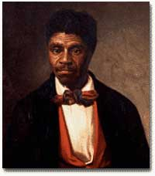
Portrait of Dred Scott by Louis Schultze, painted from a photograph.
From the 1780s, the question of whether slavery would be permitted in new territories had threatened the Union. Over the decades, many compromises had been made to avoid disunion. But what did the Constitution say on this subject? This question was raised in 1857 before the Supreme Court in case of DRED SCOTT VS. SANDFORD. DRED SCOTT was a slave of an army surgeon, John Emerson. Scott had been taken from Missouri to posts in Illinois and what is now Minnesota for several years in the 1830s, before returning to Missouri. The Missouri Compromise of 1820 had declared the area including MINNESOTAfree. In 1846, Scott sued for his freedom on the grounds that he had lived in a free state and a free territory for a prolonged period of time. Finally, after eleven years, his case reached the Supreme Court. At stake were answers to critical questions, including slavery in the territories and citizenship of African-Americans. The verdict was a bombshell.
Top of Form
Bottom of Form
- The Court ruled that Scott's "sojourn" of two years to Illinois and the Northwest Territory did not make him free once he returned to Missouri.
- The Court further ruled that as a black man Scott was excluded from United States citizenship and could not, therefore, bring suit. According to the opinion of the Court, African-Americans had not been part of the "SOVEREIGN PEOPLE" who made the Constitution.
- The Court also ruled that Congress never had the right to prohibit slavery in any territory. Any ban on slavery was a violation of the Fifth Amendment, which prohibited denying property rights without due process of law.
- The Missouri Compromise was therefore unconstitutional.
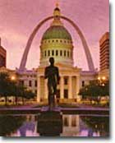
Dred Scott's battle for his freedom began at the Old Courthouse in St. Louis, Missouri.
The Chief Justice of the United States was ROGER B. TANEY, a former slave owner, as were four other southern justices on the Court. The two dissenting justices of the nine-member Court were the only Republicans. The north refused to accept a decision by a Court they felt was dominated by "Southern fire-eaters." Many Northerners, including Abraham Lincoln, felt that the next step would be for the Supreme Court to decide that no state could exclude slavery under the Constitution, regardless of their wishes or their laws.
Two of the three branches of government, the Congress and the President, had failed to resolve the issue. Now the Supreme Court rendered a decision that was only accepted in the southern half of the country. Was the American experiment collapsing? The only remaining national political institution with both northern and southern strength was the Democratic Party, and it was now splitting at the seams. The fate of the Union looked hopeless.

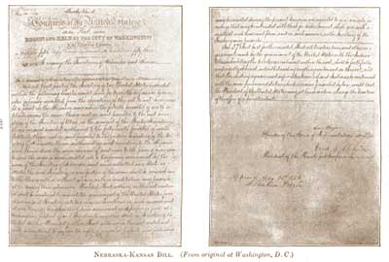
The Kansas-Nebraska Act
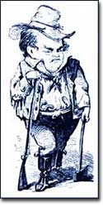
Stephen Douglas, the sponsor of the Kansas-Nebraska Act as well as the most vocal supporter of popular sovereignty, was known as the "Little Giant" because of his small stature.
The KANSAS-NEBRASKA ACT OF 1854 may have been the single most significant event leading to the Civil War. By the early 1850s settlers and entrepreneurs wanted to move into the area now known as Nebraska. However, until the area was organized as a territory, settlers would not move there because they could not legally hold a claim on the land. The southern states' representatives in Congress were in no hurry to permit a Nebraska territory because the land lay north of the 36°30' parallel — where slavery had been outlawed by the Missouri Compromise of 1820. Just when things between the north and south were in an uneasy balance, Kansas and Nebraska opened fresh wounds.
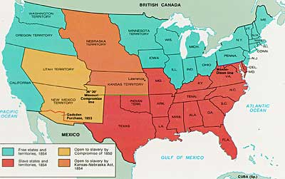
The person behind the Kansas-Nebraska Act was SENATOR STEPHEN A. DOUGLAS of Illinois. The Kansas Nebraska Act began a chain of events in the Kansas Territory that foreshadowed the Civil War. He said he wanted to see Nebraska made into a territory and, to win southern support, proposed a southern state inclined to support slavery. It was Kansas. Underlying it all was his desire to build a transcontinental railroad to go through Chicago. The Kansas-Nebraska Act allowed each territory to decide the issue of slavery on the basis of popular sovereignty. Kansas with slavery would violate the Missouri Compromise, which had kept the Union from falling apart for the last thirty-four years. The long-standing compromise would have to be repealed. Opposition was intense, but ultimately the bill passed in May of 1854. Territory north of the sacred 36°30' line was now open to popular sovereignty. The North was outraged.
The Kansas-Nebraska act made it possible for the Kansas and Nebraska territories (shown in orange) to open to slavery. The Missouri Compromise had prevented this from happening since 1820.
Top of Form
Bottom of Form
The political effects of Douglas' bill were enormous. Passage of the bill irrevocably split the Whig Party, one of the two major political parties in the country at the time. Every northern Whig had opposed the bill; almost every southern Whig voted for it. With the emotional issue of slavery involved, there was no way a common ground could be found. Most of the southern Whigs soon were swept into the Democratic Party. Northern Whigs reorganized themselves with other non-slavery interests to become the REPUBLICAN PARTY, the party of Abraham Lincoln. This left the Democratic Party as the sole remaining institution that crossed sectional lines. Animosity between the North and South was again on the rise. The North felt that if the Compromise of 1820 was ignored, the Compromise of 1850 could be ignored as well. Violations of the hated Fugitive Slave Law increased. Trouble was indeed back with a vengeance.

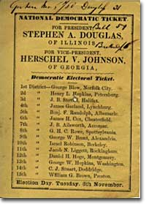
The Election of 1860 Valley of the Shadow: Two Communities in the American Civil War, Virginia Center for Digital History, University of Virginia
This Democratic ticket from Staunton, VA, showing Douglas as the party nominee is unusual because Douglas wasn't shown as the nominee for the Democratic Party in most of the South.
The Democrats met in Charleston, South Carolina, in April 1860 to select their candidate for President in the upcoming election. It was turmoil. Northern democrats felt that Stephen Douglas had the best chance to defeat the "BLACK REPUBLICANS." Although an ardent supporter of slavery, southern Democrats considered Douglas a traitor because of his support of popular sovereignty, permitting territories to choose not to have slavery. Southern democrats stormed out of the convention, without choosing a candidate. Six weeks later, the northern Democrats chose Douglas, while at a separate convention the Southern Democrats nominated then VICE-PRESIDENT JOHN C. BRECKENRIDGE.
The Republicans met in Chicago that May and recognized that the Democrat's turmoil actually gave them a chance to take the election. They needed to select a candidate who could carry the North and win a majority of the Electoral College. To do that, the Republicans needed someone who could carry New Jersey, Illinois, Indiana and Pennsylvania — four important states that remained uncertain. There were plenty of potential candidates, but in the end Abraham Lincoln had emerged as the best choice. Lincoln had become the symbol of the frontier, hard work, the self-made man and the American dream. His debates with Douglas had made him a national figure and the publication of those debates in early 1860 made him even better known. After the third ballot, he had the nomination for President.
A number of aging politicians and distinguished citizens, calling themselves the CONSTITUTIONAL UNION PARTY, nominated JOHN BELL of Tennessee, a wealthy slaveholder as their candidate for President. These people were for moderation. They decided that the best way out of the present difficulties that faced the nation was to take no stand at all on the issues that divided the north and the south.
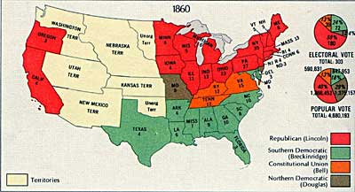
The votes of the Electoral College were split among four candidates in the 1860 presidential election. The states that Lincoln won are shown in red, Breckenridge in green, Bell in orange and Douglas in brown.
With four candidates in the field, Lincoln received only 40% of the popular vote and 180 electoral votes — enough to narrowly win the crowded election. This meant that 60% of the voters selected someone other than Lincoln. With the results tallied, the question was, would the South accept the outcome? A few weeks after the election, South Carolina seceded from the Union.

John Brown's Raid
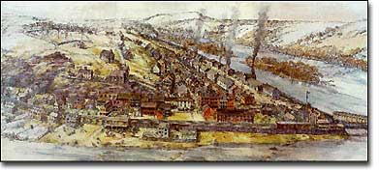
Harper's Ferry before John Brown's raid on October 16, 1859.
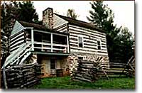
On October 16, 1859, John Brown led a small army of 18 men into the small town of HARPER'S FERRY, Virginia. His plan was to instigate a major slave rebellion in the South. He would seize the arms and ammunition in the federal arsenal, arm slaves in the area and move south along the Appalachian Mountains, attracting slaves to his cause. He had no rations. He had no escape route. His plan was doomed from the very beginning. But it did succeed to deepen the divide between the North and South.
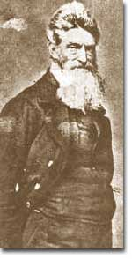
John Brown and his men stayed in this rented farmhouse in the days before the raid on Harper's Ferry. John Brown and his cohorts marched into an unsuspecting Harper's Ferry and seized the federal complex with little resistance. It consisted of an armory, arsenal, and engine house. He then sent a patrol out into the country to contact slaves, collected several hostages, including the great grandnephew of George Washington, and sat down to wait. The slaves did not rise to his support, but local citizens and militia surrounded him, exchanging gunfire, killing two townspeople and eight of Brown's company. Troops under the command of Lieutenant Colonel Robert E. Lee arrived from Washington to arrest Brown. They stormed the engine house, where Brown had withdrawn, captured him and members of his group, and turned them over to Virginia authorities to be tried for treason. He was quickly tried and sentenced to hang on December 2. John Brown's fanaticism affected many of the people around him, especially his family. Two of his sons were killed at Harper's Ferry. Brown's strange effort to start a rebellion was over less than 36 hours after it started; however, the consequences of his raid would last far longer. In the North, his raid was greeted by many with widespread admiration. While they recognized the raid itself was the act of a madman, some northerners admired his zeal and courage. Church bells pealed on the day of his execution and songs and paintings were created in his honor. Brown was turned into an instant martyr. Ralph Waldo Emerson predicted that Brown would make "the gallows as glorious as the cross." The majority of northern newspapers did, however, denounce the raid. The Republican Party adopted a specific plank condemning John Brown and his ill-fated plan. But that was not what the south saw.
Top of Form
Bottom of Form
Southerners were shocked and outraged. How could anyone be sympathetic to a fanatic who destroyed their property and threatened their very lives? How could they live under a government whose citizens regarded John Brown as a martyr? Southern newspapers labeled the entire north as John Brown sympathizers. Southern politicians blamed the Republican Party and falsely claimed that Abraham Lincoln supported Brown's intentions. Moderate voices supporting compromise on both sides grew silent amid the gathering storm. In this climate of fear and hostility, the election year of 1860 opened ominously. The election of Abraham Lincoln became unthinkable to many in the south.

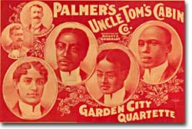

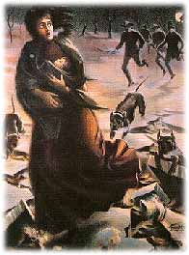
Harriet Beecher Stowe — Uncle Tom's Cabin
Kim Wells, Domestic Goddesses
Eliza is forced to flee dogs and slave-catchers in Uncle Tom's Cabin.
"So you're the little woman who wrote the book that made this great war."
This was Abraham Lincoln's reported greeting to HARRIET BEECHER STOWE when he met her ten years after her book UNCLE TOM'S CABIN was published. Although the President may have been exaggerating a bit, few novels in American history have grabbed the public spotlight and caused as great an uproar as Uncle Tom's Cabin.
Across the north, readers became acutely aware of the horrors of slavery on a far more personal level than ever before. In the south the book was met with outrage and branded an irresponsible book of distortions and overstatements. In such an explosive environment, her story greatly furthered the Abolitionist cause north of the Mason-Dixon Line and promoted sheer indignation in plantation America.
Stage plays and movies were made of the controversial abolitionist novel, Uncle Tom's Cabin, although most of the characters were played by white actors and many of the characters became stereotypical caricatures.
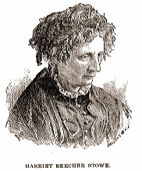
Harriet Beecher Stowe was born into a prominent family of preachers. Her father, Lyman Beecher, was one of the most renowned ministers in his generation. Her brother HENRY WARD BEECHER was already an outspoken Abolitionist, and by the mid 1850s would become the driving force behind aiding the FREE-SOIL cause in "BLEEDING KANSAS" (not permitting slavery in the new territory). While living for a short while in Cincinnati, Stowe became exposed to actual runaway slaves. Her heart ached at the wretched tales she heard. She began to write a series of short stories depicting the plight of plantation slaves.
Encouraged by her sister-in-law, Stowe decided to pen a novel. First published as a series in 1851, it first appeared as a book the following year. The heart-wrenching tale portrays slave families forced to cope with separation by masters through sale. Uncle Tom mourns for the family he was forced to leave. In one heroic scene, Eliza makes a daring dash across the frozen Ohio River to prevent the sale of her son by slave traders. The novel also takes the perspective that slavery brings out the worst in the white masters, leading them to perpetrate moral atrocities they would otherwise never commit.
Harriet Beecher Stowe lost a child in infancy, an experience that she said made her empathize with the losses suffered by slave mothers whose children were sold.
The reaction was incredible. Uncle Tom's Cabinsold 300,000 copies in the North alone. The FUGITIVE SLAVE LAW, passed in 1850, could hardly be enforced by any of Stowe's readers. Although banned in most of the south, it served as another log on the growing fire.
The book sold even more copies in Great Britain than in the United States. This had an immeasurable appeal in swaying British public opinion. Many members of the British Parliament relished the idea of a divided United States. Ten years after the publication of Uncle Tom's Cabin, the British people made it difficult for its government to support the Confederacy, even though there were strong economic ties to the South. In the end, Mr. Lincoln may not have been stretching the truth after all.

