US History: Grade 8 – Test Make Up Assignment
Age of European Exploration: Document Based Question (DBQ)

Historical Context: During the period known as the Age of Exploration and Settlement, European cultures came into contact with Native Americans. This contact proved to be very destructive to Native American culture groups.
Directions
 Answer the questions that follow each document.

 Using information from the documents below, as well as your knowledge of history write an essay which includes:

- An introduction,
- Several body paragraphs,
- And a conclusion.
DOCUMENT 1: Logbook kept by Christopher Columbus (and engraving)

Sunday, September 30, 1492 – Four tropic birds came to the ship, which is a very clear sign of land, for so many birds … show that they are not straying about, having lost themselves.
Wednesday, October 10 – The crew lost all patience, and complained of the length of the voyage, but the Admiral encouraged them in the best manner he could, explaining the profits they were about to acquire.
Thursday, October 11 – encountered a stormier sea than ever before … The crew of the Pinta … picked up a stick which appeared to have been carved with an iron tool, a piece of sugar cane, a plant which grows on land, and a board. These signs encouraged them, and they all grew cheerful.
Friday, October 12 – At two o’clock in the morning the land was discovered … Arrived on shore, they saw trees very green many streams of water, and diverse sorts of fruits. The Admiral called upon the two Captains … to bear witness that he before all others took possession of that island for the King and Queen … The people of the island gathered together … I presented them with some red caps, and strings of beads to wear upon the neck, and many other trifles of small value. They were much delighted … they seemed on the whole to me, to be a very poor people. Weapons they have none, nor are they familiar with them, for I showed them swords which they grasped by the blades, and cut themselves. They have no iron, their javelins being without it, and nothing more than sticks.
Saturday, October 13 – They came to the ship in canoes, made of a single trunk of a tree, built in a wonderful manner … some of them large enough to contain forty or forty-five men. I … strove to
learn if they had any gold … seeing some of them with little bits of this metal hanging at their noses. I learned that by going southward or steering round the island in that direction, there would be found a king who possessed large vessels of gold. I am determined to proceed onward.

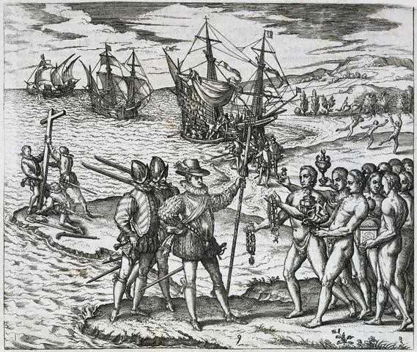
[Engraving of Columbus meeting natives.]

- What clues did the crew notice that would indicate land was near?

- Why did the crew continue on with the voyage after complaining about its length?

- Why did Columbus believe that these Native Americans knew very little about weapons?

- What was Columbus really hoping to find on this island?

DOCUMENT 2: Excerpt from Aztec Diary
“There came among us a great sickness, a general plague. It raged among us, killing vast numbers of people. Many died merely of hunger. They starved to death because there was no one left alive to care for them. The worst of this lasted 60 days, 60 days of horror.”
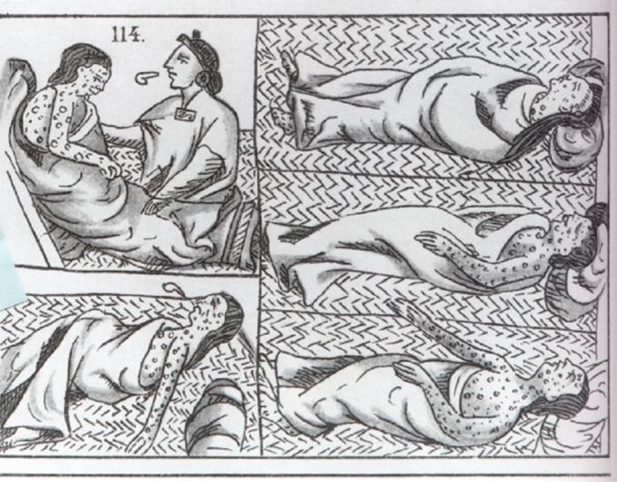

How long did the smallpox attack last?

  - What were two (2) ways that people died during this attack?

DOCUMENT 3: An Aztec Song (describing the Spanish conquest)

SONG:
And all this happened to us. We saw it, we marveled at it.
With this sad and mournful destiny We saw ourselves afflicted [suffering].
On the road lie broken arrows, our hair in disarray. Without roofs are the houses…
We have struggled against the walls of adobe, but our heritage was a net made of holes. Our shields were our protection but not even with shields could we defend ourselves...
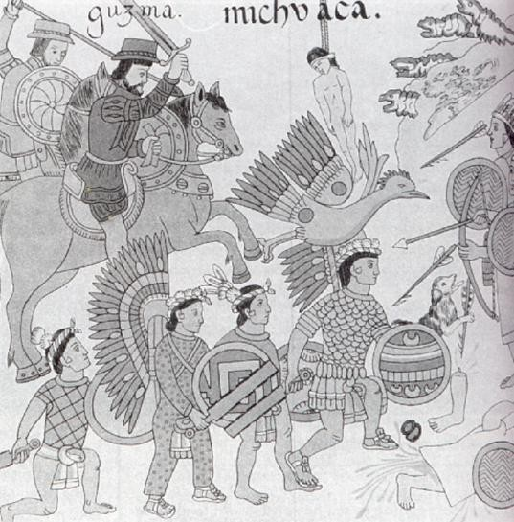
- What two weapons of the Aztecs proved ineffective against the Spanish?

- Why were the Aztec weapons ineffective?

- What is meant by the phrase, “… our heritage was a net made of holes”?

DOCUMENT 4:
Native American Population in New Spain, 1520-1610
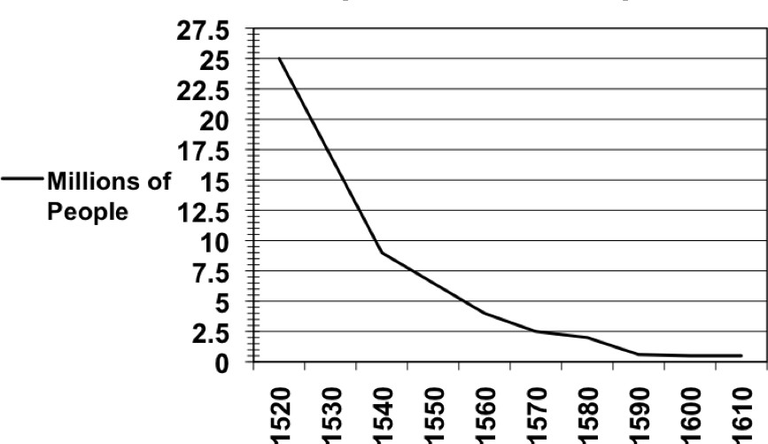

- What trend in the Native American population is shown by the graph?

- What are two reasons for the many deaths among the Native Americans?

DOCUMENT 5: Drawings of Native

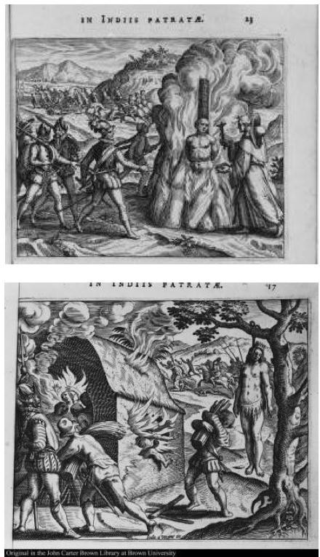
Americans Being Burned for Refusing to Convert to Catholicism

Who are the men lighting the fire?

  - Why are these Native Americans being burned?

Essay Assignment:

Task: Using information from the documents and your knowledge of United States history, write an essay demonstrating how Native American culture groups suffered hardship after coming into contact with Europeans. Your essay should contain at least three ways that Native Americans suffered after contact with the Europeans.

Directions: Write a well-organized, five paragraph essay that includes an introductory paragraph, three body paragraphs, and a concluding paragraph. Do not simply repeat the contents of the documents. Use evidence from the documents to support your prior knowledge and historical understanding. A superior essay will include historical details and additional information that you have learned in classes, online, or from textbooks. You do not have to do additional outside reading for this essay.

This outline organizer describes how to write an organized, five-paragraph essay using M.E.A.L.:
Introduction – Introduce the topic with historical context (who, what, when, where, why). And a THESIS
– such as “Native American Culture groups suffered great hardships after coming into contact with Europeans, such as (Para 1), (Para 2) and (Para3)”

Body I – First hardship they suffered (M)(Main Idea/Topic Sentence)

(E)(Example(s) = citing from document(s) to show how you know about the hardship) (A)(Analysis = discussion / opinions / inferences / connections)
(L)(Link = concluding statement related to your thesis / transition)

Body II – Second hardship they suffered (M)(Main Idea/Topic Sentence) (E)(Example(s) = citing from document(s) to show how you know about the hardship) (A)(Analysis = discussion / opinions / inferences / connections)
(L)(Link = concluding statement related to your thesis / transition)

Repeat as above for Body III – Third hardship….

Conclusion – Wrap up what you said and show you proved your point. Extra style points for connecting to the world today or other lessons in history.

